**Practical No. 6**

**Aim:** Restful services using WEB - API

**Steps:**

Step 1: create a new project select the “ASP.NET Web Application (.NET framework)” and click on next, give the project a name then select “WEB-API” and click on create.

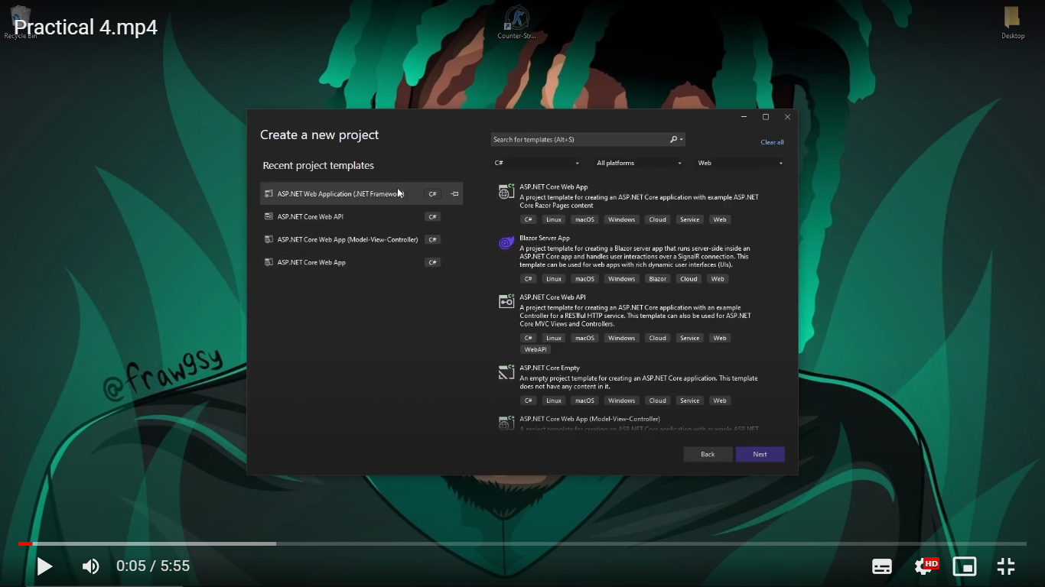

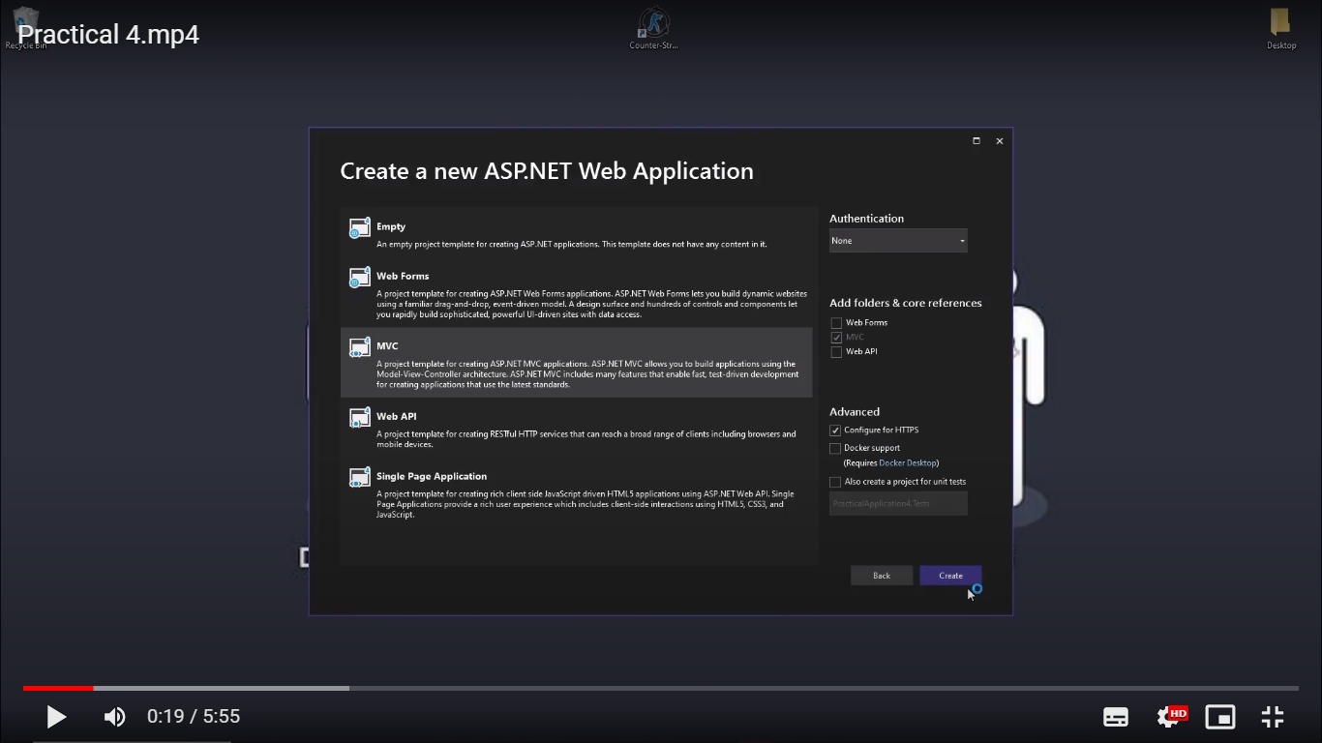

Step 2: Go to Microsoft SQL Server Management Studio and copy the server’s name, then go back to the studio click on data connections then select “Create new SQL Server Database…”, Paste the server’s name and give a new database name.

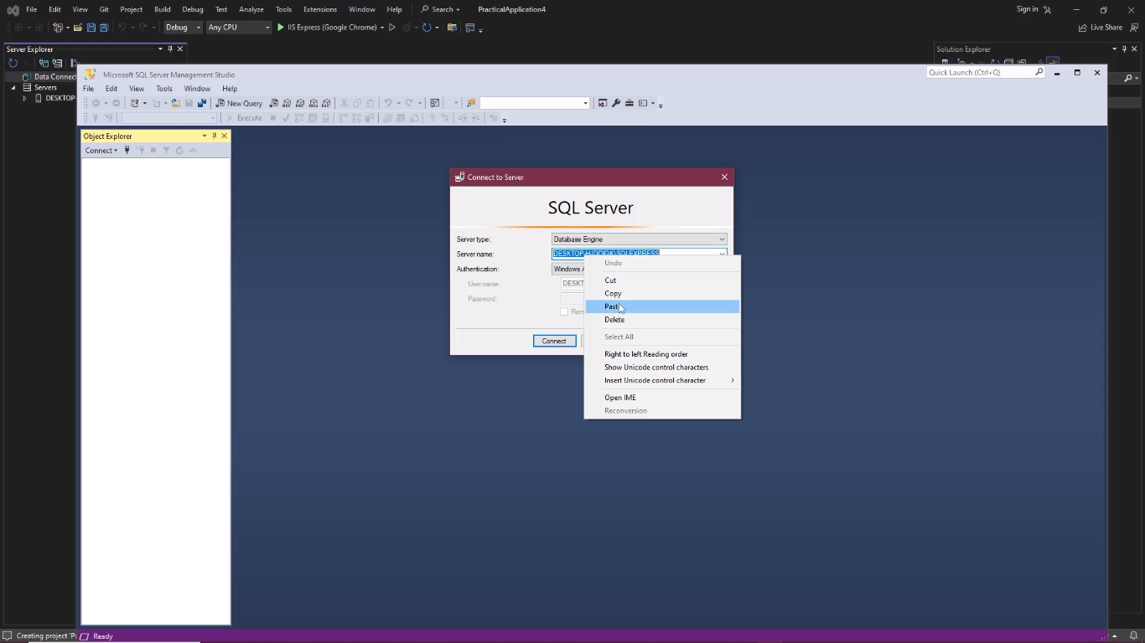

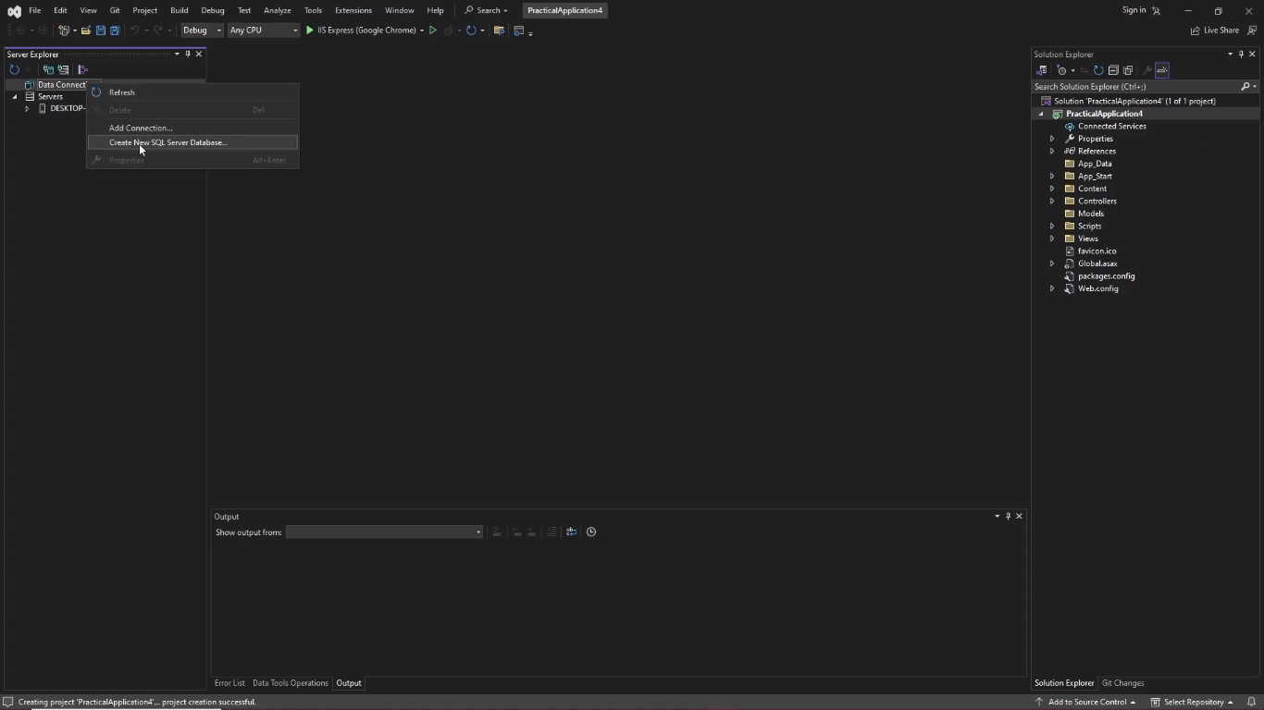

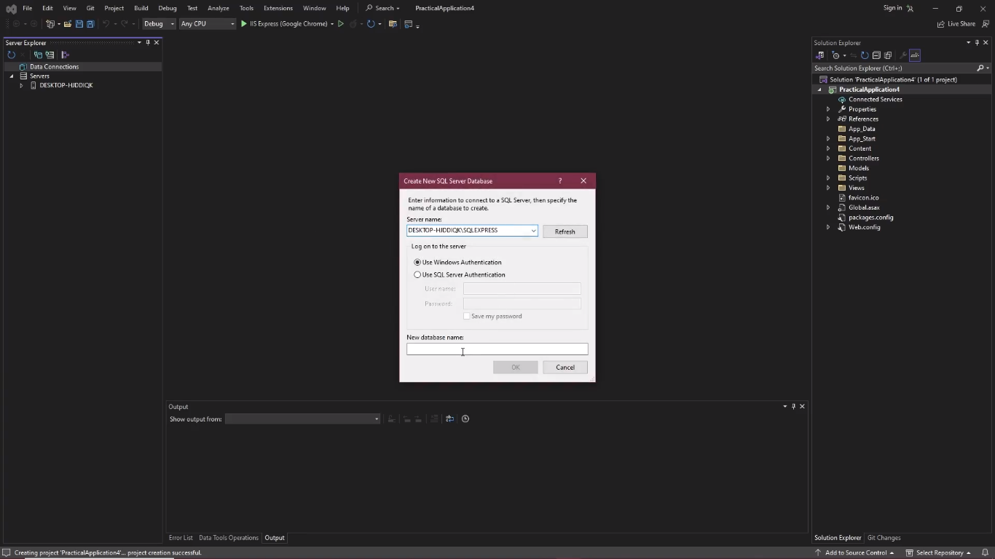

Step 3: Right click on tables and add new table, add a new item “Name” inside the table and set the Data type as “varchar (10)”, Change the name of the table to Student.

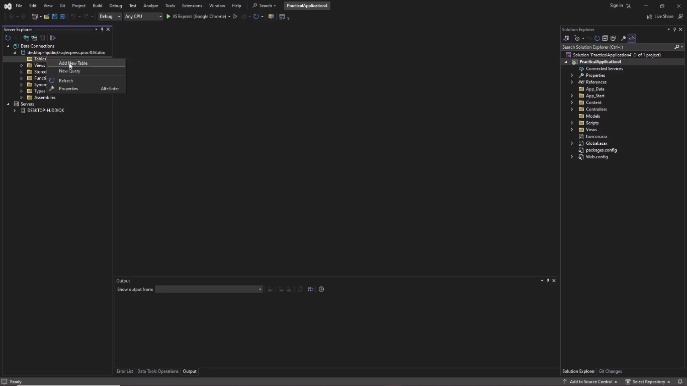

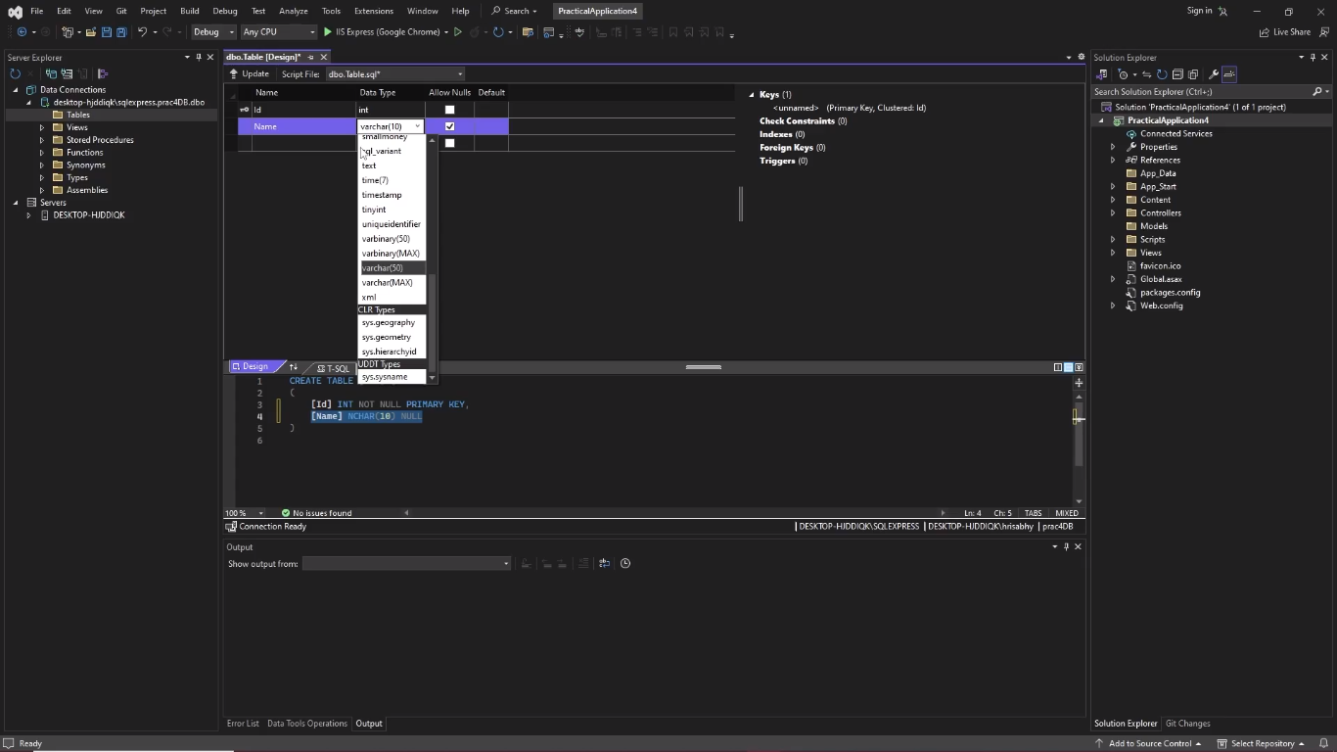

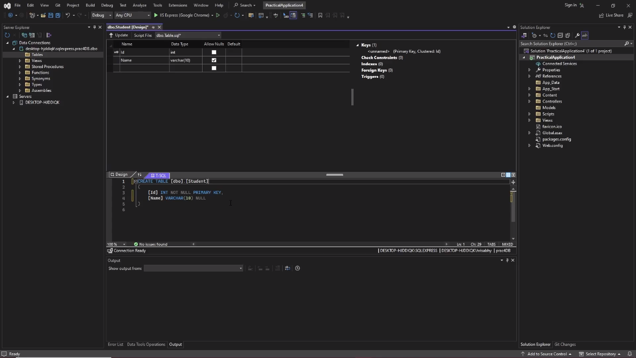

Step 4: click on the update

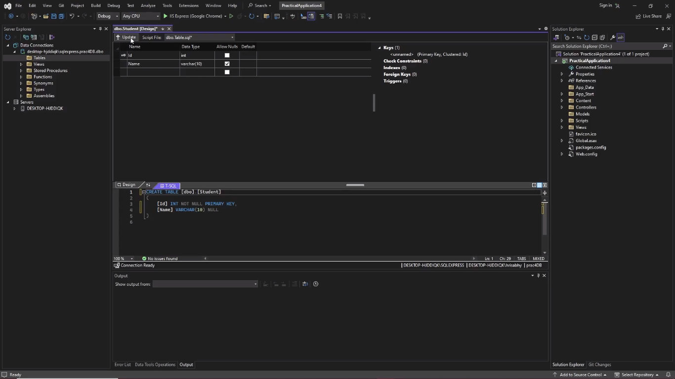

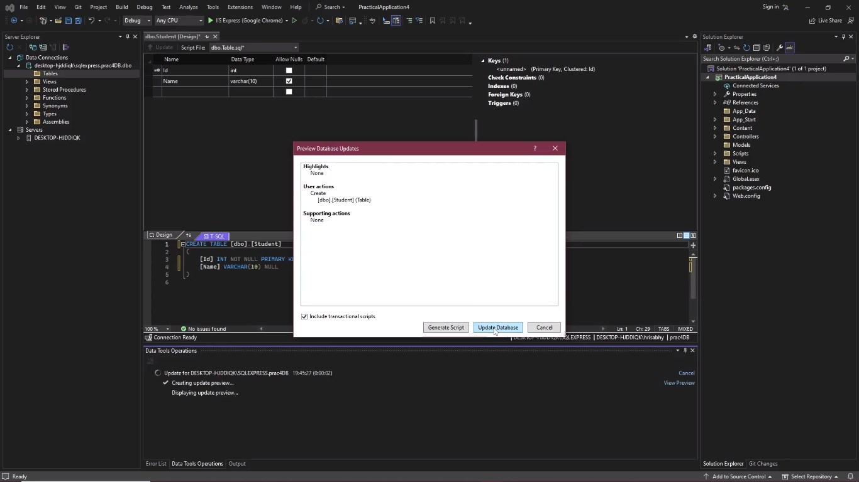

Step 5: Click on Refresh, under the tables right click on Students and click on “show table”

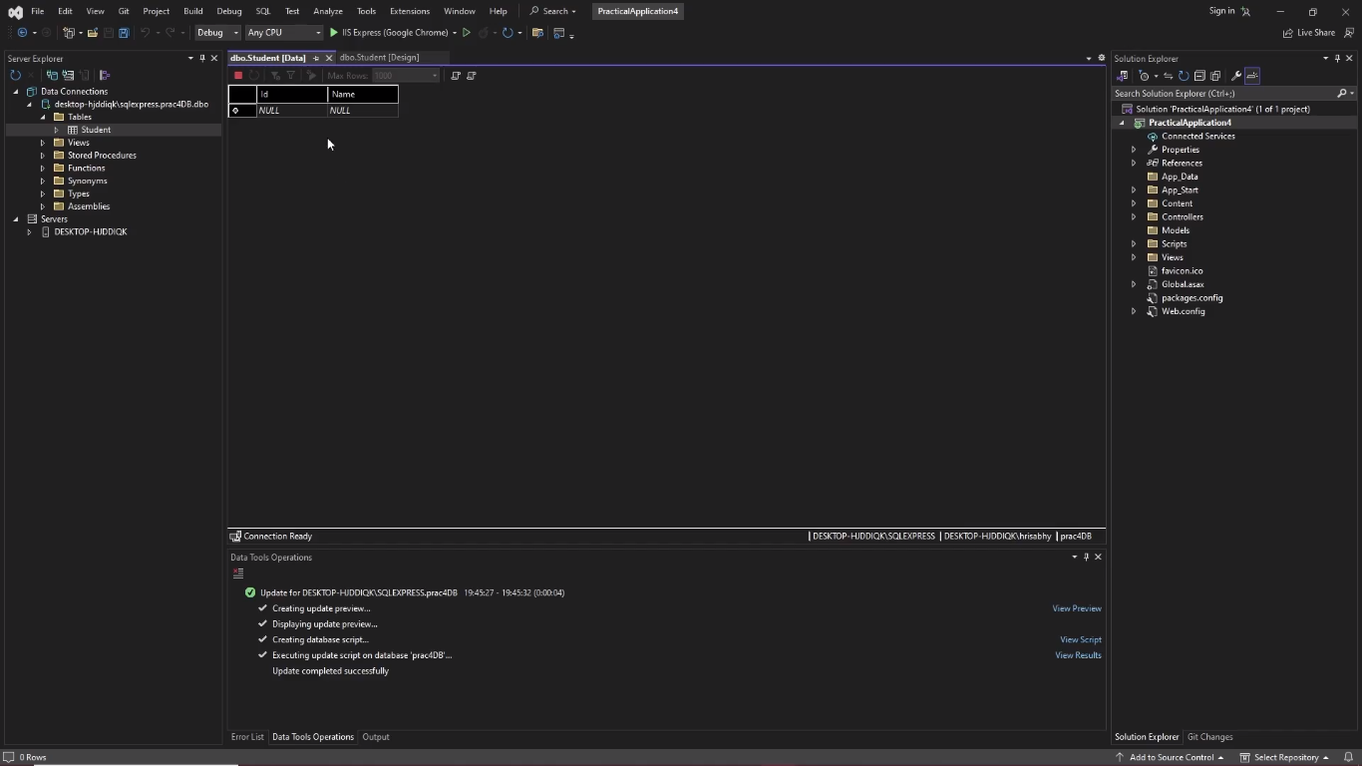

Step 6: add a few names and id to the table

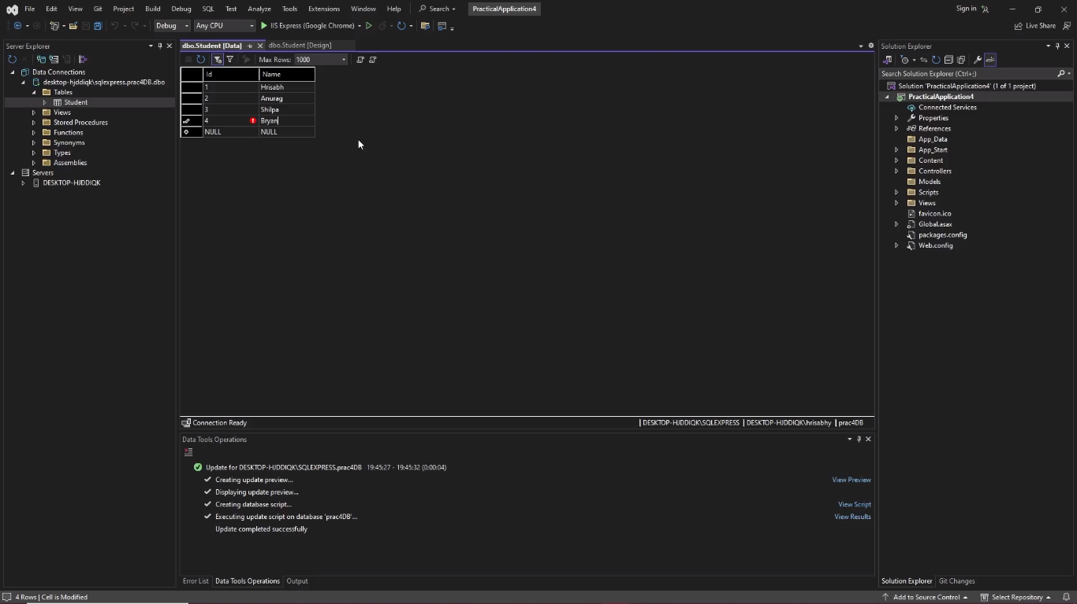

Step 7: Under the solution explorer right click on ‘models’, click on ‘add’ then select ‘New Items…’

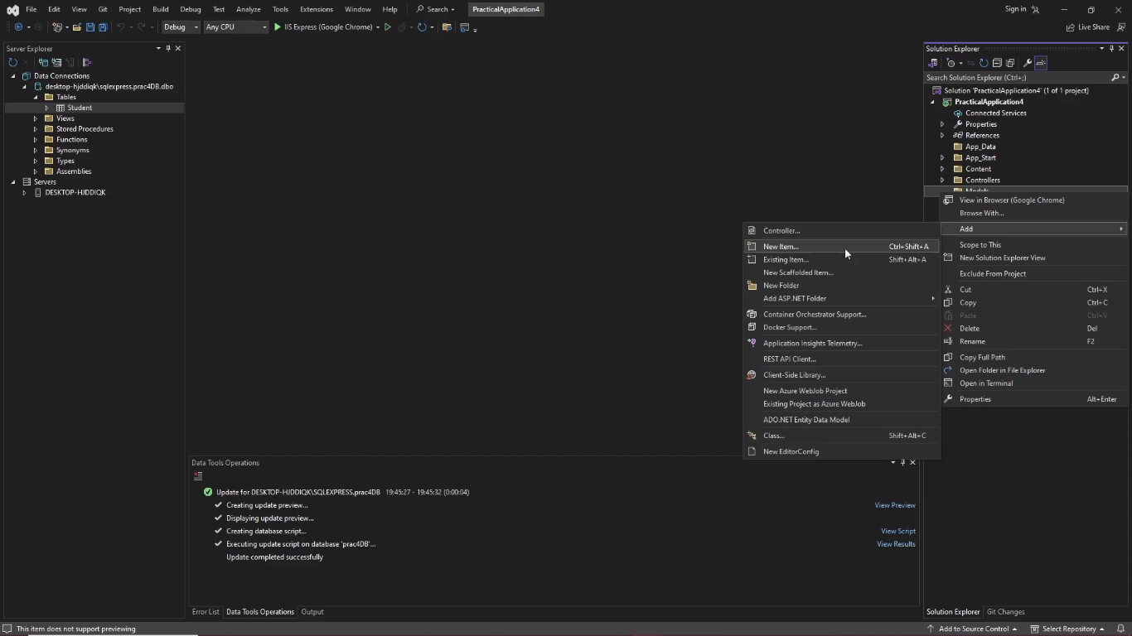

Step 8: Under ‘C#’ select ‘Data’, enter the name ‘StudentModel’ and click on add.

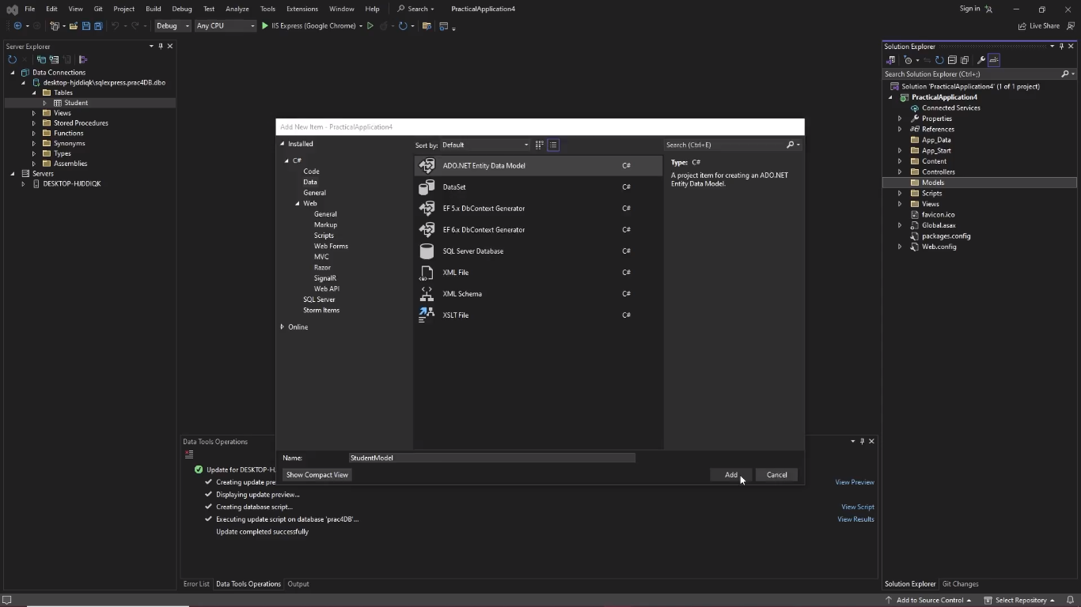

Step 9: Select ‘EF designer from database’ and click on next

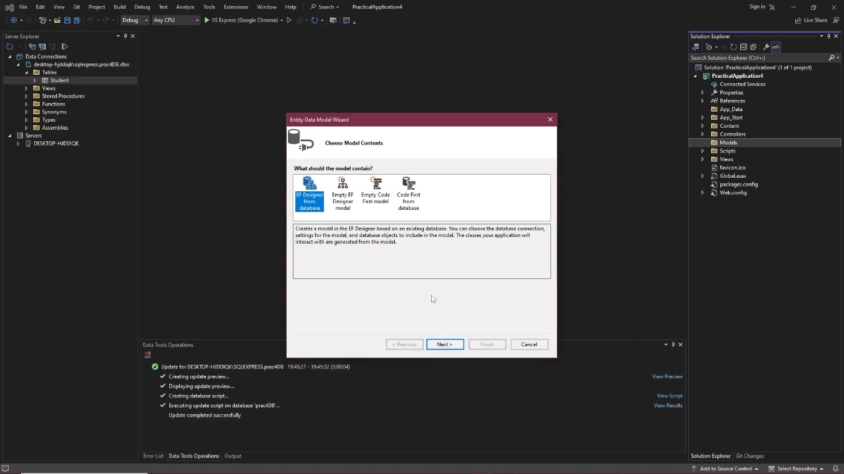

Step 10: Select ‘No’, remove your server’s name and type ‘StudentEntities’ then click on next

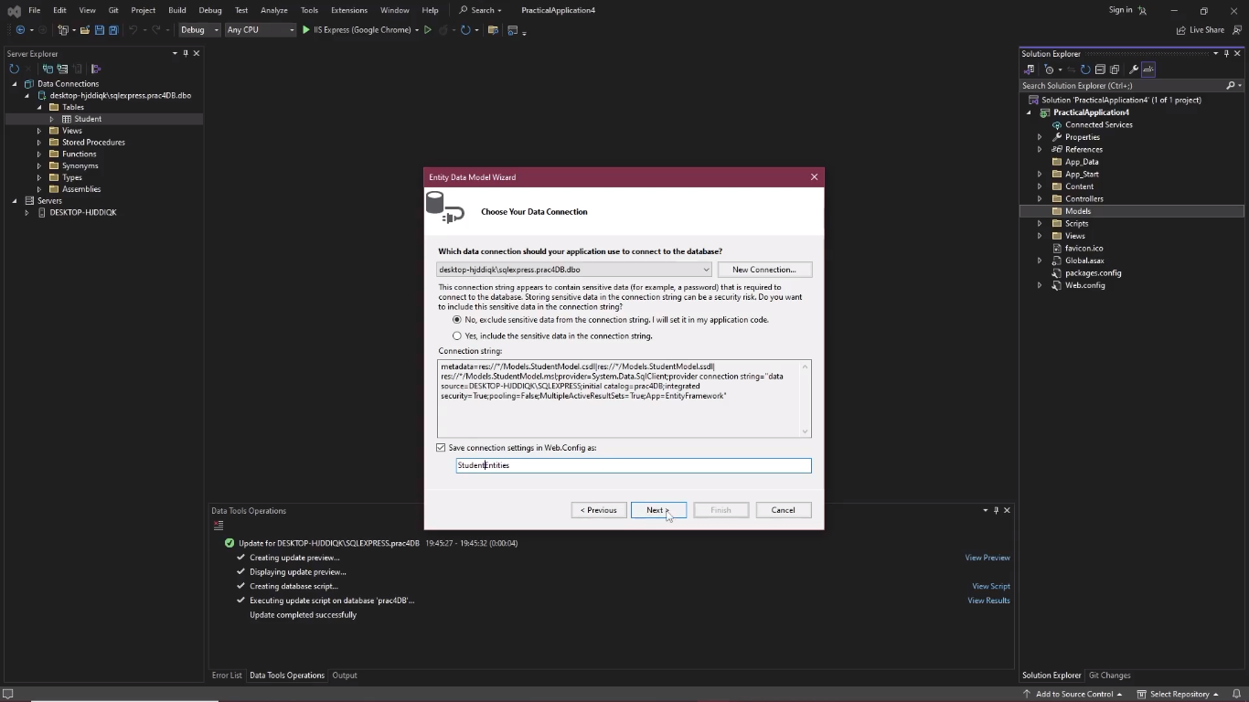

Step 11: let ‘Entity framework 6.x’ be selected

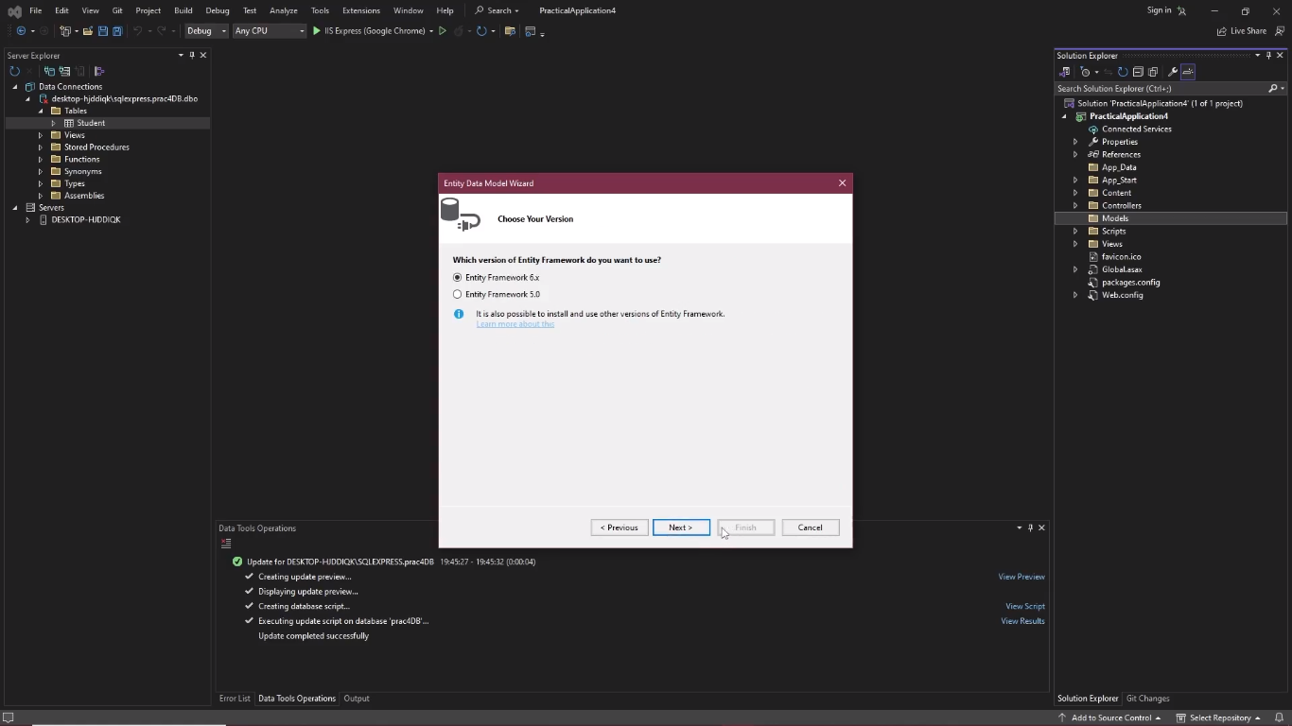

Step 12: Select the student table under dbo under Tables and click on finish

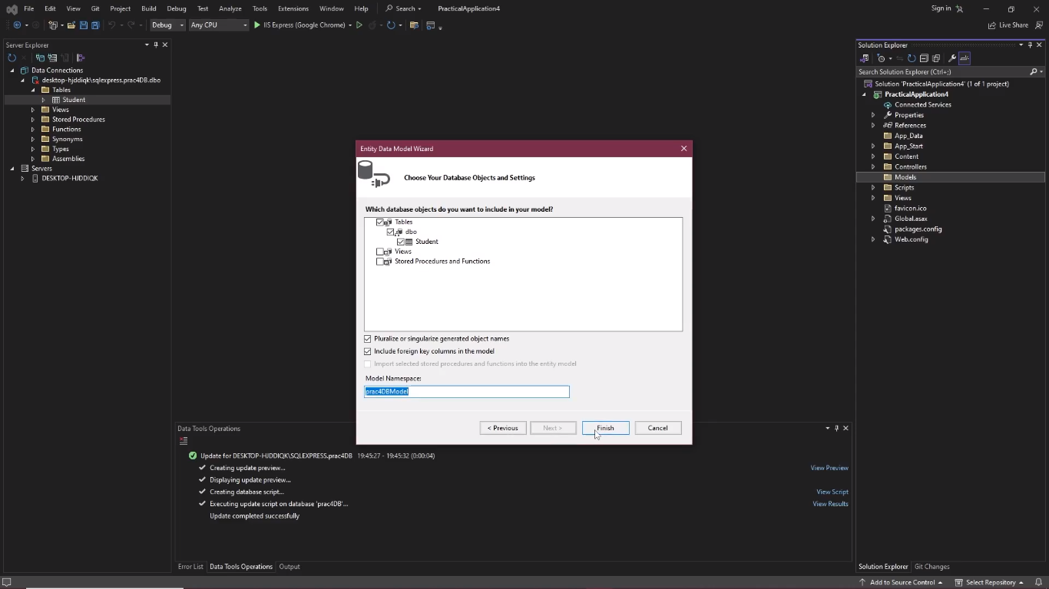

Step 13: Right click on controller in the solution explorer, click on ‘add’ then select ‘controller…’

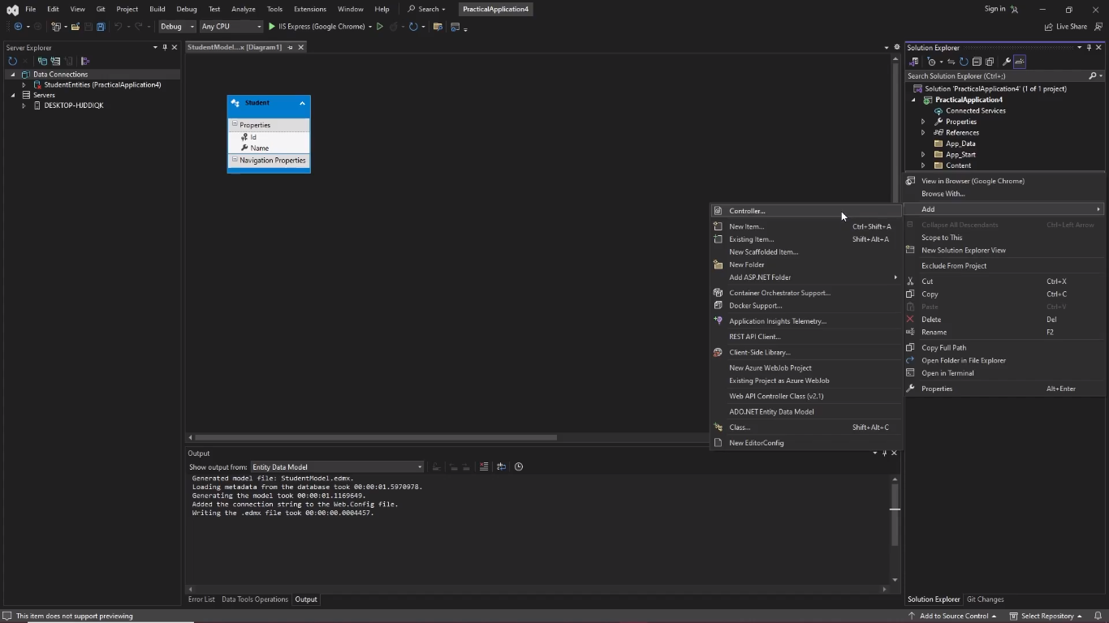

Step 14: go to Web API Select ‘WEB API 2 Controller with actions, using entity Framework’ and click on add

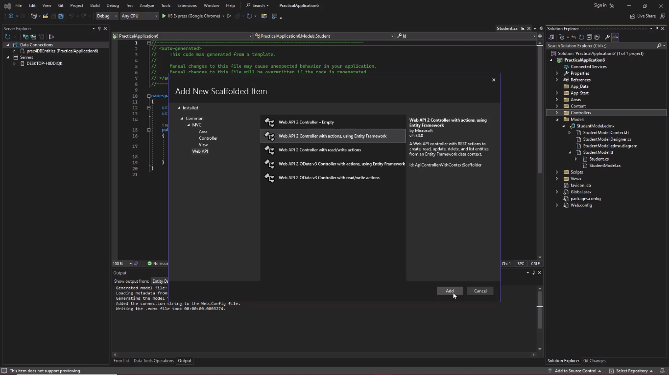

Step 15: select model class, data context class and type the controller’s name then click on add

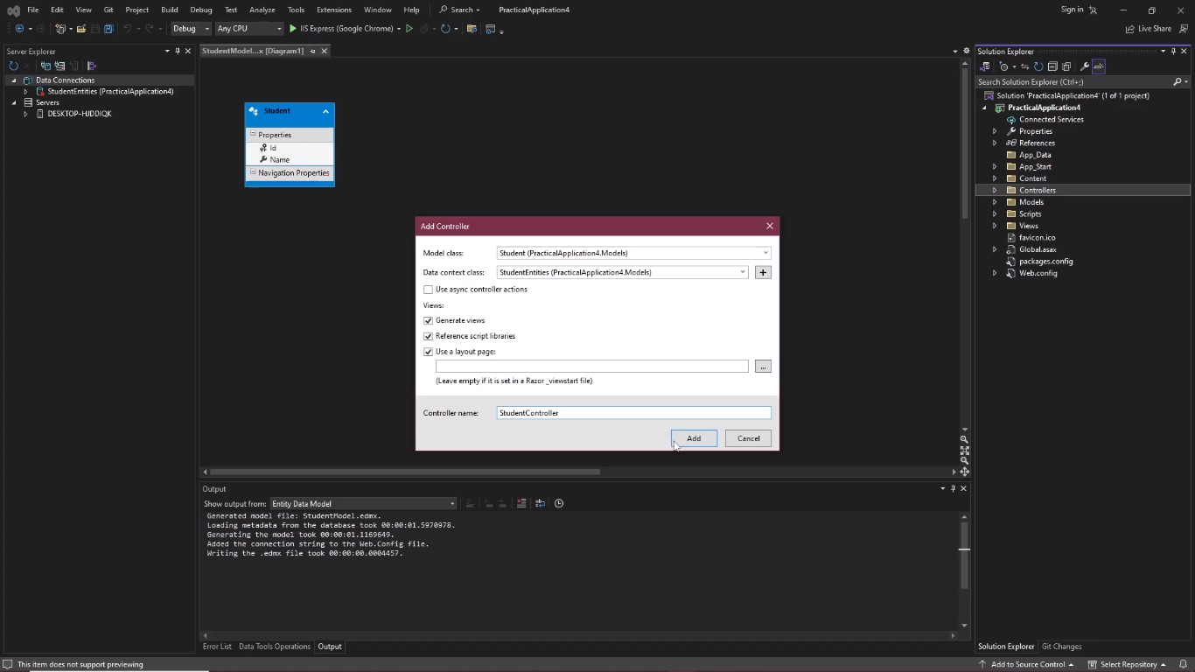

[Incase the is an error right click on the application in solution explorer and select rebuild and repeat step 13-15]

Step 16: Click on ‘IIS Express (Google Chrome)’.

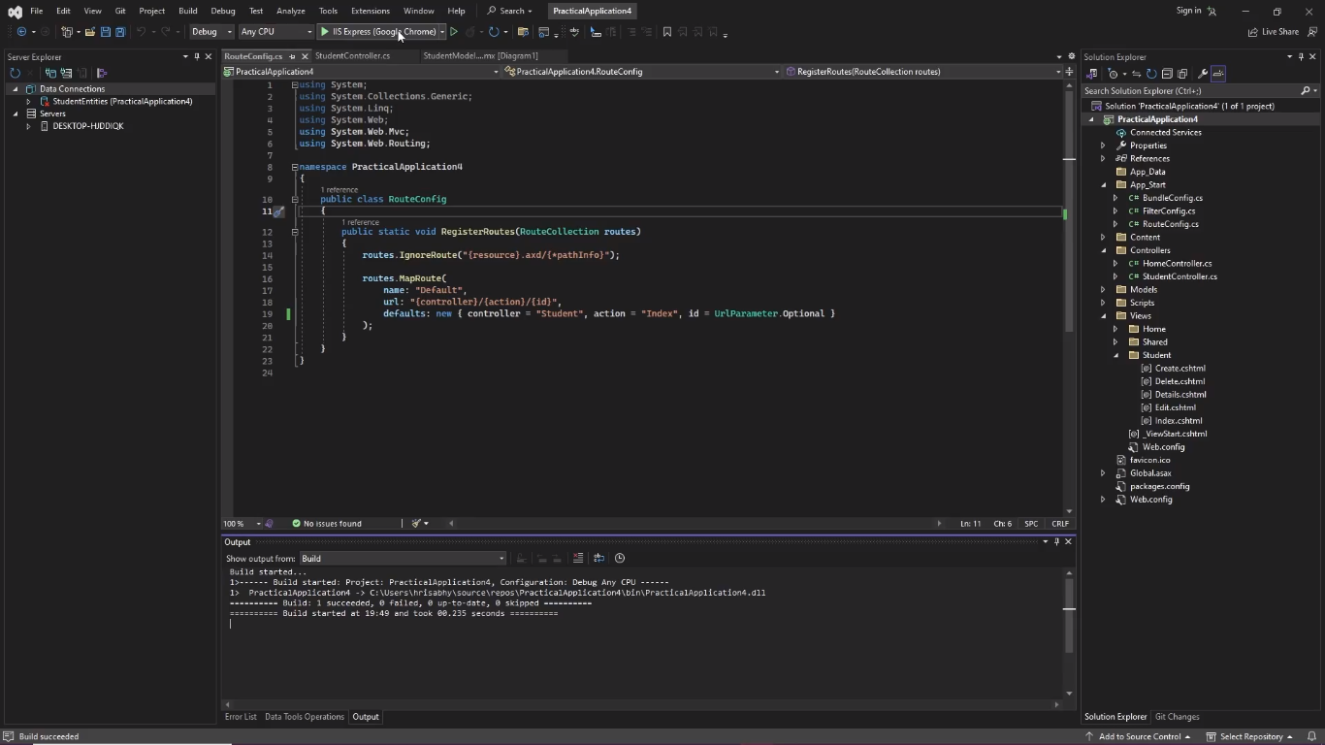

Output:

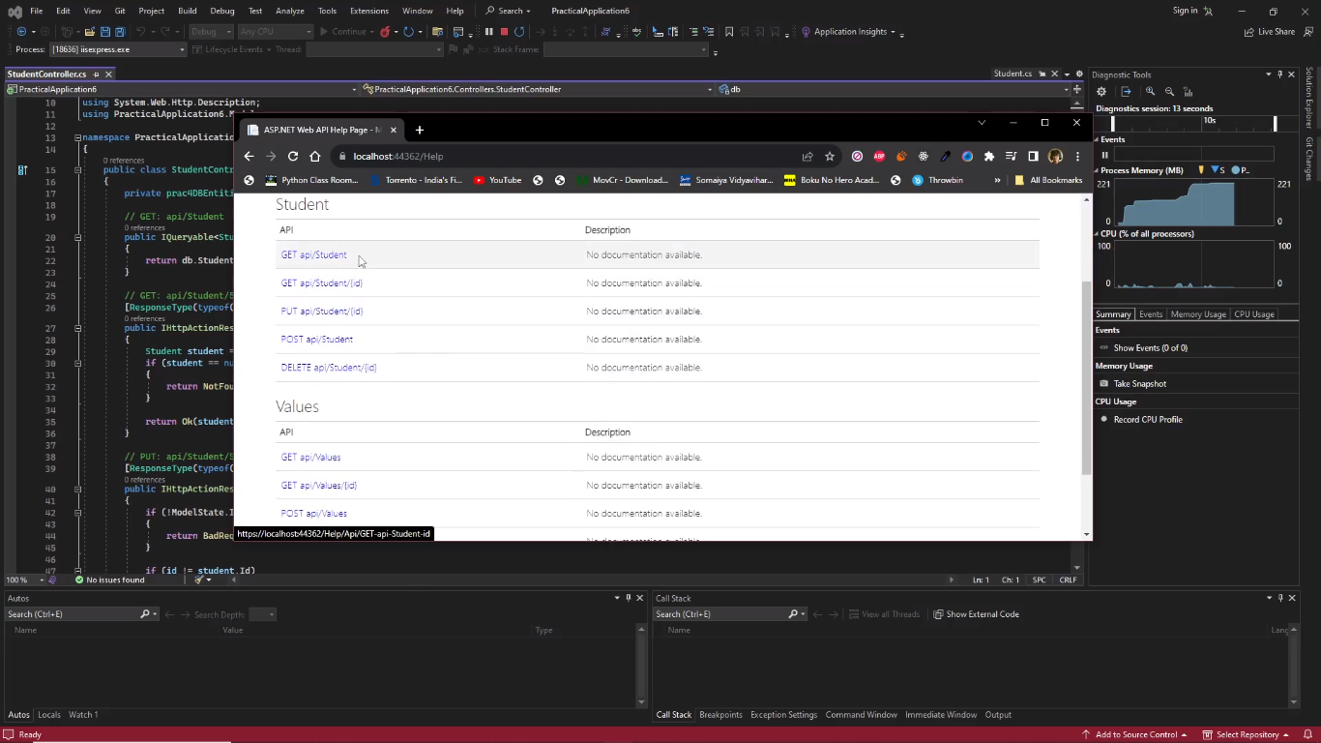

Step 17: Copy the URL go to post man click on new select HTTP

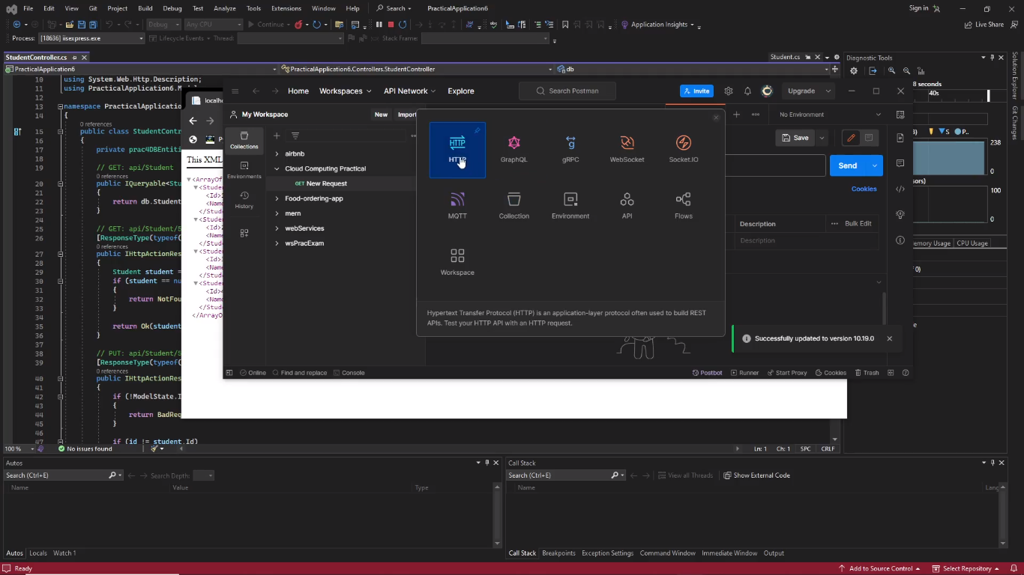

Step 16: Paste the URL and click on send

